


European Project Semester
PROJECT OUTLINE

Project dates: Mars – June 2027
Title: Explainable AI Dashboard for Liver Cancer Risk Assessment
Project activity areas: Machine Learning, Prediction Models, communication with pathologists or radiologists, diagnostic accuracy | Keywords: Deep Learning, Classification, Interpretability, Evaluation Metrics, Medical data
Tutor’s name and coordinates  Client – End-user: UTTOP - LGP  ENIT Technical Supervisor + contact:  Bernard KAMSU FOGUEM : Bernard.Kamsu-Foguem@uttop.fr  Clovis FOGUEM : cfoguem@yahoo.fr | Project origin  UTTOP - LGP
Project technical background:
Liver cancer is a major global health challenge, ranking as one of the leading causes of cancer-related deaths worldwide, with over 800,000 new cases diagnosed annually. The most common form, hepatocellular carcinoma (HCC), is often detected at an advanced stage, dramatically reducing survival rates. Early detection and precise risk stratification remain the absolute cornerstones for improving patient prognosis and clinical outcomes.
In recent years, the integration of artificial intelligence and deep neural networks into abdominal imaging (CT and MRI scans) has opened new horizons for liver oncology. State-of-the-art Deep Learning models have demonstrated significant success in automating tumor segmentation, characterizing lesions, and predicting patient survival trajectories. For instance, recent multi-centric studies utilizing convolutional neural networks (CNNs) and vision transformers (ViTs) on large-scale datasets—such as the Liver Tumor Segmentation Benchmark (LiTS)—have shown remarkable accuracy in distinguishing benign nodules from malignant HCC, thereby reducing human inter-observer variability and diagnostic delays. Despite these breakthroughs, current clinical adoption is severely hindered by the "black-box" nature of these deep models. To ensure clinical trust, there is a critical and urgent need to integrate Explainable Artificial Intelligence (XAI) frameworks that offer transparent visual and quantitative justifications for the AI's risk predictions.
Our project intends to begin with a thorough, updated literature review focusing on XAI applications in digital liver oncology. A major gap identified in recent literature is the lack of standardized benchmarking: existing models are typically trained on highly heterogeneous, localized datasets with varying imaging protocols, making direct performance comparison difficult. This project will address this limitation by evaluating XAI-driven architectures across open-source, multi-modal reference datasets (such as TCGA-LIHC and TCIA).
Additionally, this project will focus on the integration and evaluation of Gradient-weighted Class Activation Mapping (Grad-CAM) and its recent advanced variants. As a powerful visual explanation technique, Grad-CAM uses the gradients of any target concept flowing into the final convolutional layer to produce a coarse localization map, highlighting the crucial regions in the CT/MRI image that localise the liver lesions. While Grad-CAM has already demonstrated outstanding performance in enhancing clinical interpretability within various complex biomedical imaging fields—such as chest X-rays and neuroimaging—its systematic optimization and benchmarking for joint multi-phase abdominal image analysis remain a highly promising area to explore.
The project aims to involve European Project Semester (EPS) students within a highly multidisciplinary environment. The team will benefit directly from close collaboration with the medical community, leveraging the established clinical network of Prof. Bernard Kamsu Foguem. Active medical input will be essential at every stage, guiding the students through dataset selection, bounding clinical objectives for data processing, and clinically validating the generated XAI explanations.

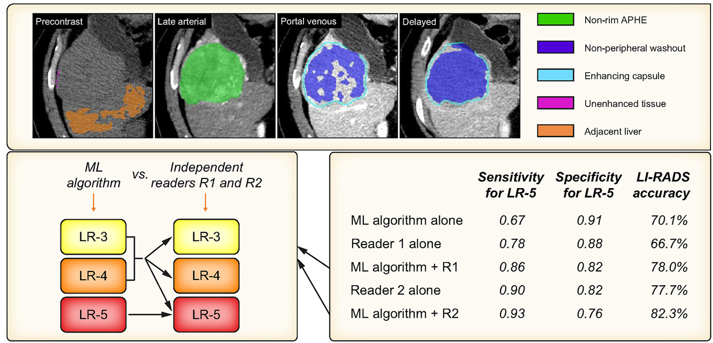

Fig. 1: liver observations using machine learning

The purpose of the current project is to provide a structured overview of the current state of Machine Learning-based liver cancer detection and outline future directions for research and clinical adoption. An emphasis would be placed on explainable machine learning—specifically through visual attention mapping like Grad-CAM—ensuring that clinicians can capture relevant knowledge from a model concerning tumor characteristics, either contained in multi-phase data or learned by the network. In concert with clinical trials, abdominal radiologists and hepatologists need to agree on a single comprehensive interpretation standard in terms of lesion assessment (such as the LI-RADS classification), terminology, reporting, and follow-up monitoring. Improving Explainability for Radiologists remains a critical challenge:
- Identification of the suspected location of liver tumors, nodules, and their vascularization features across multi-phase CT/MRI scans to help the radiologist correctly interpret and stage the disease.
- Translating these visual explanation maps into semantic clinical concepts (e.g., hyperenhancement, washout, threshold growth) and developing interpretability frameworks that are more intuitive for the radiologist needs further research."
- .
References:
[1] Chan S, Sun H, Xu Y et al. The Lancet Commission on addressing the global hepatocellular carcinoma burden: comprehensive strategies from prevention to treatment The Lancet, 2025; 406, 731-778.
[2] Sung H, Filho AM, Laversanne M, et al. Global cancer statistics 2024: GLOBOCAN estimates of incidence and mortality worldwide for 34 cancers in 186 countries. CA Cancer J Clin. 2026;e70090. doi:10.3322/caac.70090
[3] Jianing Fan, Shuyang Zhu, Guohua Cheng, Yunkun Lu, Xiao Liang, Junjie Xu, Artificial intelligence in multimodal research for liver cancer, Trends Open, 2026, , ISSN 3117-3470, https://doi.org/10.1016/j.treopn.2026.08.015.
[4] Nickolai Joel Matuschewski, William Baker, Julius Chapiro, Julien Calderaro, Artificial intelligence and personalised medicine in liver cancer, Journal of Hepatology, Volume 85, Issue 4, 2026, Pages 712-726, ISSN 0168-8278, https://doi.org/10.1016/j.jhep.2026.04.017.
[5] Terry Cheuk-Fung Yip, Hamish Innes, Grace Lai-Hung Wong, Peter Jepsen, Surveillance of patients at risk of liver cancer: Expert opinions, Journal of Hepatology, Volume 85, Issue 4, 2026, Pages 669-682, ISSN 0168-8278, https://doi.org/10.1016/j.jhep.2026.03.017
[6] Lingling Yuan, Yutong Gu, Yan Han, Tianming Du, Marcin Grzegorzek, Chen Li, Exploring transparency in pathological image analysis: A comprehensive review of explainable artificial intelligence (XAI) techniques, Computer Science Review, Volume 60, 2026, 100863, ISSN 1574-0137, https://doi.org/10.1016/j.cosrev.2025.100863
[7] C Alqaralleh BAY, Alksasbeh MZ, Kulakli A, Zreikat AI. An intelligent healthcare framework for hepatocellular carcinoma diagnosis based on aggregated learners from biomedical data utilising explainable artificial intelligence. Sci Rep. 2026 Feb 16;16(1):9357. doi: 10.1038/s41598-026-39871-z. PMID: 41699121; PMCID: PMC13003069.
[8] Alfarhood M, Alotaibi S, Abuhaimed A, Alalwan A. Leveraging deep learning and explainable AI for effective liver tumor classification from CT scan images. Front Oncol. 2026 Jun 2;16:1836325. doi: 10.3389/fonc.2026.1836325. PMID: 42311265; PMCID: PMC13268880
[9] Yao Y, Chen X, Wei Z. Machine learning prediction of complications after surgery in cirrhotic patients: Integrating nutritional risk with liver function. Arab J Gastroenterol. 2026 Aug;27(3):382-390. doi: 10.1016/j.ajg.2026.06.009. Epub 2026 Jul 27. PMID: 42509096.
[10] Sébastien Mulé, Maxime Ronot, Mario Ghosn, Riccardo Sartoris, Giuseppe Corrias, Edouard Reizine, Vincent Morard, Ronan Quelever, Laura Dumont, Jorge Hernandez Londono, Nicolas Coustaud, Valérie Vilgrain, Alain Luciani, Automated CT LI-RADS v2018 scoring of liver observations using machine learning: A multivendor, multicentre retrospective study, JHEP Reports, Volume 5, Issue 10, 2023, 100857, ISSN 2589-5559, https://doi.org/10.1016/j.jhepr.2023.100857

Studied topics:
- Literature review of machine learning and deep learning algorithms applied to liver cancer detection and segmentation.
- Summarization of how AI algorithms help differentiate malignant hepatocellular carcinoma (HCC) from benign liver nodules (e.g., hemangiomas, focal nodular hyperplasia) in abdominal imaging.
- Exploration of various deep learning architectures (such as CNNs and Vision Transformers) and explainable AI frameworks (specifically Grad-CAM) for multi-phase liver tumor classification.
- Evaluation of clinical class imbalance, model interpretability (visual saliency mapping), and generalizability across heterogeneous multi-centric datasets (e.g., LiTS, TCGA-LIHC).
- Development of a typical use-case and experimental testing to enhance the clinical applicability, trustworthiness, and integration of XAI-based diagnostic systems for abdominal radiologists

